ICS Reference Architecture Design Guide
Table of Contents
1. Network Segmentation 2
Firewall Rule Design Concept: 2
Switch & VLAN: 2
2. Remote Access (jump server) 3
Jump Server Hardened Configuration: 3
PAM Security Configuration: 4
3. Anti-Virus 4
4. Log Collection/Monitoring 4
5. Historian Server Segmented 5
6. Vulnerability & Patch Management 5
7. Manufacturing Access Management 6
APPENDIX: 7
ICS Reference Architecture Design 7
ICS Remote Access Design: 8
FW Rule Configurations: 8

Network Segmentation
Network Segmentation must be established with at least the enterprise, manufacturing DMZ and manufacturing zones separated by a Palo Alto firewall. The Palo Alto firewall will have the following features licensed and enabled:
- Threat Prevention
- WildFire (threat analysis)
- URL Filtering
Firewall rule requests must go through the existing corporate process by submitting a request via service now.

Firewall Rule Design Concept:
- Deny all, permit none except for the traffic absolutely required for business needs.
  - See List standard Exception List in Appendix
- All rules should contain both source & destination IP, TCP/UDP port and protocol in use.
- Rules should only allow devices internal to the control network the ability to establish connections outside the control network.
- Rules should be added to deny hosts outside the control network (e.g. corporate network) from initiating connections with the hosts on the control network.

Switch & VLAN:
Switches within the manufacturing zone are EIS standards using managed Cisco switches. They will range from 24-48 ports per switch pending on the model. Any switch ports not in use shall be disabled. Virtual local area networks (VLANs) can be used on the cisco switches to logically segment the traffic between VLAN IDs 400-599:
VLAN ID | Description
VLAN 410 | Batch Servers
VLAN 420 | DMZ
VLAN 430 | LAB
VLAN 440 | PLC’s
VLAN 500 | Manufacturing Identity
VLAN 501 | WSUS Patch Management
VLAN 502 | Remote Access (jump server)
VLAN 503 | Historian
VLAN 504 | Engineer Workstations
VLAN 505 | Control Servers
VLAN 520 | Security Cameras
VLAN 521 | Key card readers

Remote Access (jump server)
Remote Access can be used to allow 3rd party support or remote plant engineers the capability to connect into the plant’s manufacturing zone to troubleshoot or manage the control system environment. This can be accomplished using a Microsoft Windows Server using the remote desktop services (terminal services) using the remote desktop protocol (RDP).
Access will be managed through Ecolab’s privileged access management (PAM) system and will be restricted using a newly created Ecolab enterprise (GLOBAL) active directory security group organized by site. Once access is setup and successful authentication to pam.ecolab.com, the user will be able to check out the jump server account and automatically initiate the connection into the jump server that resides locally at the plant within the designated DMZ. If a user is off the Ecolab network, they must connect to the enterprise VPN solution to authenticate.
From the jump server, the user will be able to connect into the control system device needed within the manufacturing zone using 2 approved & secure protocols. For windows systems remote desktop protocol (RDP) can be used and for linux/unix based systems secure shell (SSH) can be used.
The process for creating a new Ecolab enterprise identity must follow the corporate process that is already defined using workday & service now (IT Help Desk). All terminations must go through the same process.
Global AD Security Groups that will need to be created for PAM:
Global AD Security Groups | Purpose
AppA-PAM-SiteName-Users | Plant & 3rd party support that have a remote access need
AppA-PAM-SiteName-Admin | Ecolab IT Administrators
Local Jump Server Accounts that will need to be created:
Local Accounts | Purpose
svc-PAM-SiteName-User  - Add to Windows ‘Remote Desktop User’ role. | Account is managed by PAM –  Plant & 3rd party support will checkout account when they need remote access
svc-PAM-SiteName-Admin | Managed by PAM - Ecolab IT Administrators will checkout account when they have admin needs

Jump Server Hardened Configuration:
- system not on the Ecolab enterprise domain
- internet access disabled (firewall)
- all accounts managed by PAM
- Qualys agent installed for ongoing vulnerability scanning
- anti-virus (Endgame) installed w/ ongoing definition updates
- System logs monitored & archived by our SOC (e.g. windows OS event viewer logs: application, security, system) using the Elastic Beat.
- Network Time Protocol (NTP) set to time.ecolab.com
- up to date security patching using Ecolab managed WSUS
- unnecessary services disabled
- unnecessary 3rd party apps not installed or removed
- disable terminal services mapping for client audio, com port, drive, clipboard and printing
- RDP Encryption Level to High and TLS 1.2
- network level authentication (NLA) – enabled by default in Windows Server 2012 R2

PAM Security Configuration:
- Hardened appliance
- MFA enabled
- 24-hour password rotation for all accounts configured on jump server
- Audit trail reporting
- 24/7 SOC monitoring
- DVR session recording
- Optional approval workflow for jump server access.
  - Note this is recommended, but at the plant’s discretion.
Reference: see appendix for ICS remote access design diagram & FW Rule Configurations.

Anti-Virus
Used to provide anti-virus (AV) protection from the management server within the enterprise zone to servers and workstations within the manufacturing zone. The anti-virus enterprise standard is Elastic Endgame.

Log Collection/Monitoring
Used to collect and monitor logs via our security operations center (SOC) through SecureWorks. Monitored devices should be the following, but not limited to:
- Firewalls
- Switches
- Critical servers/workstations
- HMIs (where applicable)
Network time protocol (NTP): the NTP service on any device needs to be set to a standard configuration using: time.ecolab.com. This will ensure all logs use a standardized time server for proper log correlation and triage.
FW Log Monitoring: The firewall logs will be sent to Panorama and monitored via our Security Operations Center (SOC) through Ecolab’s managed service with SecureWorks.
Note it is important to contact our Security Operations team to make sure they account for any new firewalls being deployed to reassure security monitoring.
FW Log Monitoring Validation: Operations Security will need to validate the FW logs are being monitored via Ecolab’s Security Operations Center (SOC).
Windows Log Collection: A Elastic Beat can be used to capture windows logs this way the logs can get to the centralized log collector without interruption.
Note: When possible TCP should be used over UDP.
Elastic Beat Installation: Contact Security Operations team for agent.
Validation Steps: Operations Security will need to validate the agent is sending logs to Ecolab’s centralized log collector after the firewall has been put in place.
Log Retention: The collection of logs will have a set log retention to further aid in investigations conducted by our incident response (IR) team.

Historian Server Segmented
Used to transfer or collect telemetry from the manufacturing zone to the enterprise zone. The historian typically has interfaces that collects the telemetry within the manufacturing zone and forwards this information to a historian server within the DMZ and then to enterprise zone. This is done via a unidirectional firewall rule. It is important that the historian servers within the enterprise, dmz & manufacturing zone stay patched from both an operating system & application perspective.

Vulnerability & Patch Management
Ecolab Global GRC Information Security can provide a Qualys agent to be installed on compatible devices within the manufacturing or DMZ zone with routine reporting to plant personnel on security vulnerabilities deemed low, medium or high as well as security configuration issues identified.
Validation: Project team resource to confirm with GRC Information Security team to validate agent is reporting in correctly after firewall has been put in place.

Windows Server Update Services (WSUS) can be used to patch all window servers/workstations within the DMZ & manufacturing zone. For the DMZ servers (jump server) updates will automatically be pushed via our patching cycle managed by IT. For manufacturing windows devices, updates can be advertised via WSUS, but not enforced because of compatibility with control software. This means it is the plant personnel responsibility to stay up to date on windows security patches in conjunction with vendor support.
Reference: see appendix for ICS Reference Architecture Design.
Validation: Project resource from IT infrastructure team to validate updates are being received after firewall has been put in place.

Manufacturing Access Management
Used to provide an identity to enforce the concept of authentication, authorization & accounting within the manufacturing zone that is separate from the user’s identity within the enterprise zone. It is the responsibility of the plant personnel to create & manage the manufacturing identity. Plants can use the recommended active directory domain for centralized access management and computer group policy management. Alternatively, local accounts can be used, but must be unique and must follow the ICS cyber security checklist as well as be in compliant with Global Information Security’s policies and standards.
Reference: see appendix for ICS Reference Architecture Design.

APPENDIX:

ICS Reference Architecture Design

ICS Remote Access Design:
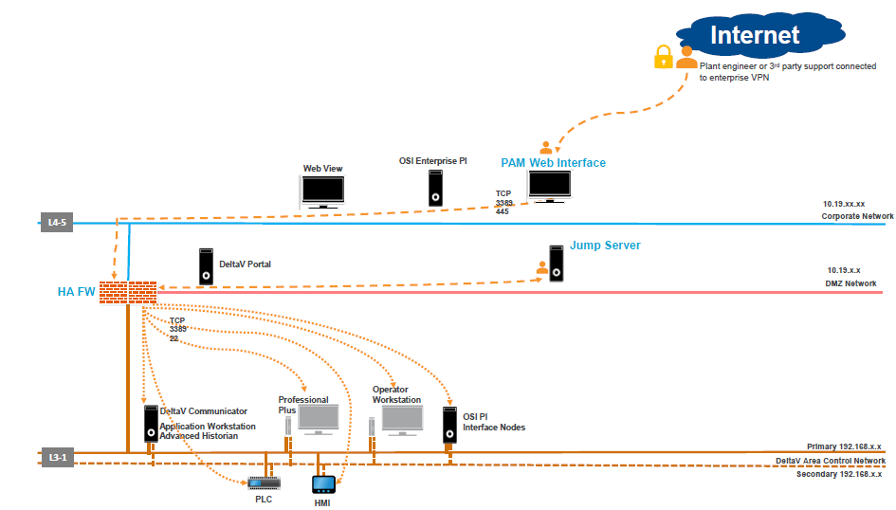

FW Rule Configurations:

Name | Source Zone | Source Address | Destination Zone | Destination Address | Application | Service | URL Category
Qualys Scanner Block | Enterprise | Qualys | AccessControl;  DMZ;  Labs;  PlantPrimary | any | any | any | any
SNOW Block | Enterprise | SNOW-Servers_Prod | AccessControl;  Labs;  PlantPrimary | any | any | any | any
Ping-Trace Allow | any | any | any | any | icmp;  ping;  traceroute | application-default | any
NTP Allow | DMZ;  PlantPrimary;  PlantSwitches | any | Enterprise | any | ntp | application-default | any
DNS Allow | DMZ;  PlantPrimary | any | Enterprise | 3903-DELCC-DDI-DNSDHCP-1;  3911-NLAMS-DDI-DNSDHCP-1;  AZHCDCIDADWE01P;  AZHCDCIDADWE02P;  CIDDCADS01 | dns | application-default | any
OCSP Allow | DMZ;  PlantPrimary | any | Enterprise | any | ocsp | application-default | any
JumpServer Access | Enterprise | AZSHRIEPJBWE01P | AccessControl;  DMZ;  Labs;  PlantPrimary | any | ms-rdp;  ssh;  ssl;  web-browsing | any | any
Endgame Allow | AccessControl;  DMZ;  Labs;  PlantPrimary | any | Enterprise | ecl.endgameone.com | ssl | tcp-443 | any
MS-Update Allow | AccessControl;  DMZ;  Labs;  PlantPrimary | any | Enterprise | any | ms-product-activation;  ms-update;  ssl;  windows-push-notifications | application-default | MS-Updates
SCCM Allow | DMZ;  PlantPrimary | any | Enterprise | NapervilleSCCM-Servers | ms-sms;  ms-update;  ssl;  web-browsing;  webdav | any | any
Plant SQL Allow Out | PlantPrimary | any | Enterprise | CIDDCSQL02 | ms-ds-smb-base;  msrpc-base;  mssql-db-base;  mssql-db-unencrypted;  netbios-ns;  netbios-ss | application-default | any
WebSeason Allow In | Enterprise | any | PlantPrimary | H-10.145.221.41;  H-10.145.221.42 | any | tcp-2048 | any
TEC-Labelprinters Allow In | Enterprise | CIDDCPRT01 | PlantPrimary | 3913-Labelprinter_NATs | any | TCP-8000 | any
HP-Printer Allow In | Enterprise | any | PlantPrimary | NeuraLabel-Printer_NAT | hp-jetdirect;  snmp-base;  snmpv1 | application-default | any
Check-Scales Allow In | Enterprise | any | PlantPrimary | 3913-CheckScales_NATs | any | tcp-1234;  tcp-55000 | any
PLC-Devices Allow In | Enterprise | CIDDCPRD01 | PlantPrimary | H-10.145.221.17 | web-browsing | application-default | any
FTP Allow Out | PlantPrimary | H-192.168.6.40 | Enterprise | CIDDCPRD01 | ftp | any | any
AD-Srv PLP Allow  [rule disabled] | PlantPrimary | any | Enterprise | AZHCDCIDADWE01P;  AZHCDCIDADWE02P;  CIDDCADS01;  CIDDCADS02 | ActiveDirectory_Apps | application-default | any
MixingPC01 Out | PlantPrimary | H-192.168.6.24 | Enterprise | CIDDCPRT01 | ms-ds-smb-base;  ms-ds-smbv3;  msrpc-base;  netbios-ss | application-default | any
MixingPC01 Out-1 | PlantPrimary | H-192.168.6.24 | Enterprise | AZHCDCIDADWE01P;  AZHCDCIDADWE02P;  CIDDCADS01 | ms-ds-smb-base;  ms-ds-smbv3 | application-default | any
PrintServer AD-Srv Allow  [rule disabled] | DMZ | BEIEPPRNTMG01P | Enterprise | AZHCDCIDADWE01P;  AZHCDCIDADWE02P;  CIDDCADS01;  CIDDCADS02 | ActiveDirectory_Apps | application-default | any
KMS DMZ-ENT Allow | DMZ | BEIEPPRNTMG01P | Enterprise | USEAGADKMSMS01P;  USEAGAN0097P | ms-kms | tcp-1688 | any
PrintServices Allow In | Enterprise;  PlantPrimary | any | DMZ | BEIEPPRNTMG01P | ms-ds-smb-base;  ms-ds-smbv3;  snmp-base;  snmpv1 | application-default | any
PrintServices Allow Out | DMZ | BEIEPPRNTMG01P | Enterprise;  PlantPrimary | any | snmp-base;  snmp-trap;  snmpv1 | application-default | any
CIDDCLABO01 Allow In | Enterprise | CIDDCLABO01 | Labs | H-10.145.218.2;  H-10.145.218.3 | any | tcp-8014 | any
CIDDCLABO01 FTP-PLP Allow | Enterprise | CIDDCLABO01 | PlantPrimary | H-10.145.221.41;  H-10.145.221.42 | ftp | any | any
SSH ENT-PLS Allow | Enterprise | 10.0.0.0-8 | PlantSwitches | any | ftp;  ssh | application-default | any
FTP PLS-ENT Allow | PlantSwitches | any | Enterprise | any | ftp | application-default | any
TACACS PLS-ENT Allow | PlantSwitches | any | Enterprise | defraisepsn01p.ecolab.com;  nlcolisepsn1.ecolab.com;  useagisepsn.ecolab.com;  usnapisepsn1.ecolab.com | tacacs-plus | application-default | any
Monitoring PLS-ENT Allow | PlantSwitches | any | Enterprise | Eco - SNMP Monitoring;  Network_Monitoring | snmp-trap;  tftp | application-default | any
Monitoring ENT-PLS Allow | Enterprise | 3913-BEIEP-NMARMIS-MDF-9538;  Network_Monitoring | PlantSwitches | any | ping;  snmp-base;  snmpv1;  snmpv2 | application-default | any
SmartLicense PLS-ENT Allow | PlantSwitches | any | Enterprise | tools.cisco.com;  tools1.cisco.com;  tools2.cisco.com | ssl | application-default | any

